HIGH PLAIN  FALL CARNIVAL | 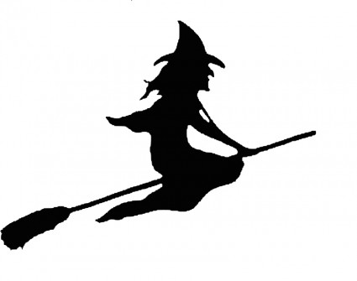

Come for a fun night with friends in costume!!!
WHERE: High Plain Elementary
WHEN: Friday, October 20, 2017 ~ 5:00 – 8:00 pm
WHAT: NEW THIS YEAR ~ Mad Science Halloween-themed Show! Scavenger Hunt, Forest of Fear*, Carnival-themed games*, Face Painting* & Tattoos, Jail Bail* –have your friend or parent “arrested” and thrown into jail. “Criminals” then have your friends and family bail you out! Pizza and Popcorn available*
COST: $10.00 per person (including adults) or $30 max per family
Items with an * will be a small additional fee
REGISTRATION DEADLINE: Wednesday, October 11th
Please make all forms attn. to Josephine Dunn
For questions email jodunn3@gmail.com
Don’t miss this first big event of the year. Family fun for all ages!!
Child(ren) __________________________________ Grade: __________ (Please print)
___________________Grade: __________ ___________________Grade: __________
___________________Grade: __________ ___________________Grade: __________
Please note: Children must be accompanied by an adult
Name:_____________________________Email:______________________________________
No. of family members ____ x $10.00 OR Max Family Rate x $30 = Total $__________
(Cash/Check payable to HPE PTO)
If you are able to volunteer, please mark your availability: Set Up____ During____CleanUp:_____

