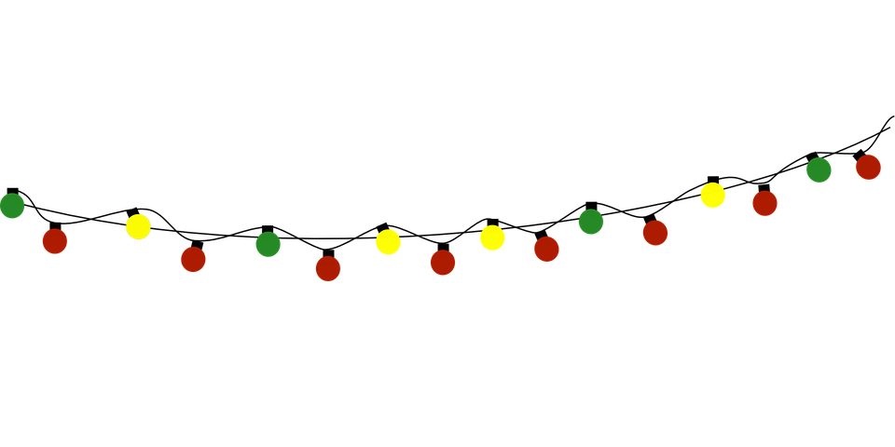

Vendor Application

Name ________________________________________________

Business Name (if applicable) __________________________________

Mailing Address __________________________________________

Telephone ___________________ Email ______________________

Description of what you are selling _________________________________

____________________________________________________

One Vendor Space (bring your own table) _____ ($25)

6 or 8 Foot Table Rental _____ (Additional $10 – limited supply)

* Application Fees are non-refundable
* Application and payment (check to HPE PTO) due by November 29, 2023
* Applications processed on a first-come, first-served basis
* Set up begins at 12:00 PM, vendors must be fully set up by 1:45 PM
* Vendors, please do not begin tearing down until 4:45 PM

*I understand and agree that High Plain Elementary School and PTO are not responsible for accidents, theft, damage, or loss during the event. Cancellations will not be refunded.*

Signature _______________________ Date __________

Contact Jessica Healey at [info@highplainpto.org](mailto:info@highplainpto.org) for questions.

*High Plain Elementary School*

*333 High Plain Rd., Andover, MA 01810*